"This aircraft has factory installed, extended range fuel cells," says a mechanic. "The cells are sealed wing bays—or 'wet wing' fuel cells located in each wing tip. These wing tip fuel cells were found leaking fuel through the fuel vent tubes (P/N 60-170010) on both sides. The cause of the leak was found to be the deterioration of the sealant around the tube slip-joint fittings. Also present in the fuel cells was an excessive amount of particulate contamination. This *(debris)* is deteriorated fuel tank sealant that failed to remain bonded to the inner tank surfaces. These particles were trapped in multiple locations throughout the entire fuel storage system with no way of draining, accessing, or even *(detecting)* their presence. The upper wing skin must be removed to access the trouble areas in the wing tip fuel cell—given inadequate inspection panel locations. The addition of a second inspection panel to the aft, inboard area of the wing tip fuel cell may be necessary to *(facilitate detection)* of this discrepancy. *(This is)* a potentially dangerous condition as fuel can enter the wing vent system, or *(these particles)* may cause fuel contamination and *(engine failure)."*

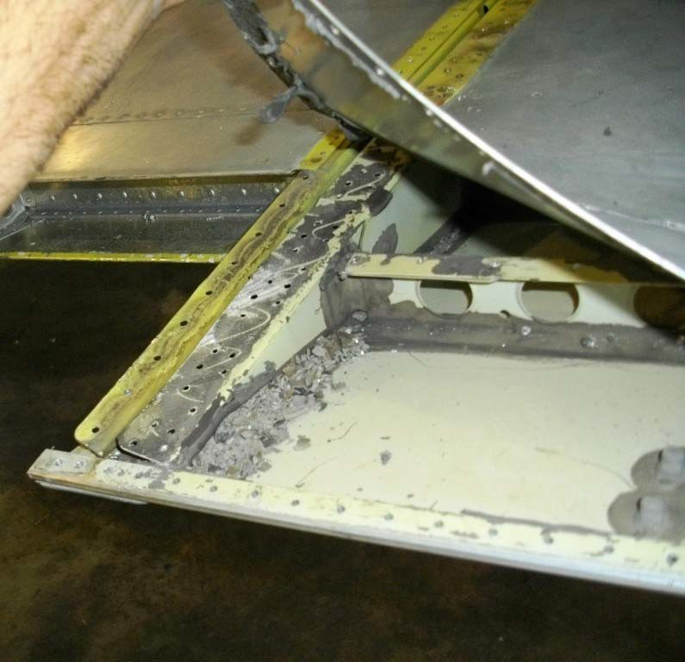

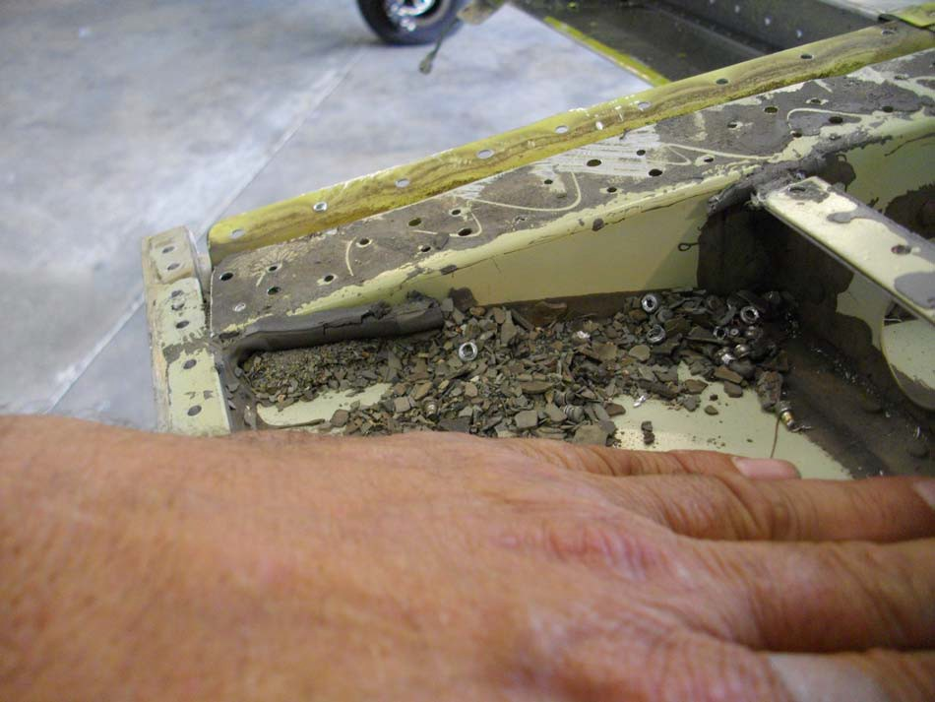

Part Total Time: (Unknown)